
Report
Summitted to
Dr. Kwankamol Nongpong

Summitted by
Thit Lwin Win Thant (ID: 6540122)
Kaung Khant Lin (ID: 6540131)
Thust Thongsricharoen (ID: 6714508)

CSX4212 (541)
Semester 2/2025

Project Title:
Comparative Sentiment Analysis: Monolingual vs. Multilingual Models for English and Thai

1) Abstract
This project investigates the performance trade-offs between monolingual sentiment classifiers and a single multilingual classifier for English and Thai. We fine-tuned three models, english-model, thai-model, and multilingual-model using a consistent label space (positive / neutral / negative) and compared them on held-out evaluation sets. Performance was measured primarily with Macro F1 and Accuracy, supplemented by A/B comparisons (ΔF1) and confusion-matrix-based error diagnosis. Results show that the multilingual model substantially improves Thai performance over the Thai-only baseline while slightly underperforming the English-only model on English datasets.

2) Introduction & Motivation
Multilingual transformer models (e.g., XLM-RoBERTa) provide a “one model for many languages” approach. A key question is whether multilingualism reduces performance due to capacity dilution or improves performance through cross-lingual transfer. In this project we:
- Train an English-only model for sentiment analysis
- Train a Thai-only model for sentiment analysis
- Train a multilingual model jointly on English + Thai data
- Compare predictive quality and diagnosed errors using confusion matrices
- Quantify gains/losses using A/B delta comparisons

3) Repository Overview
Repository: thit2003/NLP_term_project
Trained Models: https://drive.google.com/drive/folders/1qIO985HH8blVzyAKcxD29iZCENzUc_eH?usp=sharing
Key folders:
- Data/
- Data/twitter_sentiment/ English Twitter sentiment dataset (train.csv, test.csv)
- Data/wisesight-sentiment/ Thai Wisesight dataset (kaggle-competition/ folder with train/test text files)
- All_Models/
- Model folders: All_Models/english_model/, All_Models/thai_model/, All_Models/multilingual_model/
- CLI inference scripts: All_Models/english_model.py, All_Models/thai_model.py, All_Models/multilingual_model.py, All_Models/English_Multi.py, All_Models/Thai_Multi.py
- Final_Evaluation/
- Final_Evaluation/Evaluation.py — evaluation script (confusion matrix + metrics)
- Final_Evaluation/Comparison.py — A/B comparison script
- Final_Evaluation/ab_results.json — stored A/B results from prior evaluation runs
- Readme.md — project overview and goals

4) Datasets
4.1 English Datasets
a) SST-2 (Stanford Sentiment Treebank)
- Source: Hugging Face glue/sst2
- Labels: binary (positive/negative)
- Unified mapping:
- SST-2 positive → positive
- SST-2 negative → negative
- Neutral does not exist in SST-2

b) Twitter Sentiment
- Repo location: Data/twitter_sentiment/
- Files: train.csv, test.csv
- test.csv is formatted as text,label per line; labels are positive/neutral/negative
- Used for English training and evaluation as a 3-class sentiment task

4.2 Thai Dataset
Wisesight Sentiment Corpus
- Repo location: Data/wisesight-sentiment/kaggle-competition/
- Files:
- train.txt, train_label.txt
- test.txt, test_label.txt
- Original labels: pos, neu, neg, q
- Unified mapping:
- pos → positive
- neu → neutral
- neg → negative
- q → neutral

4.3 Label Standardization
We use a consistent label ID mapping across models:
- positive → 0
- neutral → 1
- negative → 2

This mapping is stored in model config files (id2label/label2id).

5) Model Architecture
To keep comparisons fair, the project uses a consistent transformer-based sequence classification setup across models (as stated in Readme.md):
- Backbone: XLM-RoBERTa base for multilingual modeling
- Head: Sequence classification head (single-label classification)
- Output: 3 sentiment classes (positive/neutral/negative)

Model artifacts are stored under:
- All_Models/english_model/
- All_Models/thai_model/
- All_Models/multilingual_model/

Each contains:
- config.json
- model.safetensors
- tokenizer.json, tokenizer_config.json
- training_args.bin

6) Methodology & Training Pipeline
Based on Readme.md, the pipeline consists of:
1) Data preparation
- Standardize labels into positive/neutral/negative
- Use established train/test splits from datasets

2) Fine-tuning runs
- Run 1 (english-model): fine-tune on SST-2 + Twitter sentiment (English-only)
- Run 2 (thai-model): fine-tune on Wisesight (Thai-only)
- Run 3 (multilingual-model): fine-tune on combined SST-2 + Twitter + Wisesight

3) Inference concept
- Monolingual deployment uses language identification (LID) to route to the correct monolingual model
- Multilingual deployment uses a single model for all inputs

7) Evaluation Methodology
7.1 Primary Metrics
As defined in Readme.md:
- Macro F1 (primary)
- Accuracy (secondary)

7.2 A/B Comparison (Model-to-Model Gains)
We compute ΔF1 (and ΔAccuracy) between:
- english-model vs multilingual-model on English datasets
- thai-model vs multilingual-model on Thai dataset

This is implemented in Final_Evaluation/Comparison.py.

7.3 Confusion Matrices
Confusion matrices are generated to diagnose systematic errors (e.g., neutral vs negative confusion). This is implemented in Final_Evaluation/Evaluation.py.

7.4 Note on SST-2 Evaluation
SST-2 is binary. For SST-2 we compute macro-F1 only over classes that exist:
- positive (0) and negative (2)
Neutral is excluded from SST-2 scoring.

8) Results
8.1 A/B Results (from Final_Evaluation/ab_results.json)
A = monolingual model, B = multilingual model, Δ = B - A.

English: Twitter (EN, 3-class)
- A (english-model): Accuracy 0.808998, Macro F1 0.812417
- B (multilingual-model): Accuracy 0.789191, Macro F1 0.792454
- ΔF1 = -0.019964, ΔAcc = -0.019808

English: SST-2 (EN, 2-class)
- A (english-model): Accuracy 0.918578, Macro F1 0.918573
- B (multilingual-model): Accuracy 0.917431, Macro F1 0.917877
- ΔF1 = -0.000696, ΔAcc = -0.001147

Thai: Wisesight (TH, 3-class)
- A (thai-model): Accuracy 0.653328, Macro F1 0.563533
- B (multilingual-model): Accuracy 0.757666, Macro F1 0.711464
- ΔF1 = +0.147931, ΔAcc = +0.104338

8.2 Summary of Findings
- The multilingual model provides a large performance gain on Thai (Wisesight), improving Macro F1 by about +0.148.
- On English datasets, the multilingual model slightly underperforms the English-only model:
- Twitter Macro F1 decreases by about -0.020
- SST-2 Macro F1 decreases by about -0.001 (almost unchanged)

9) Confusion Matrix & Error Analysis (How to generate and include)
The repository provides Final_Evaluation/Evaluation.py, which outputs:
- final_report/overall_metrics.json
- final_report/confusion_matrix.csv
- final_report/confusion_matrix.png
- final_report/top_misclassified.csv

9.1 Confusion Matrix on each model
9.1.1 Confusion Matrix on English monolingual model
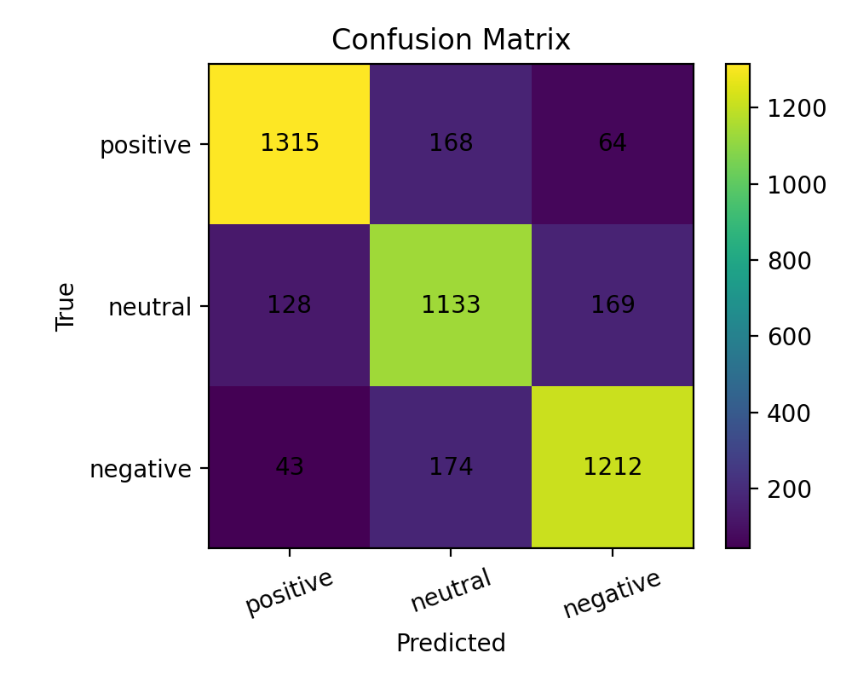 9.1.2 Confusion Matrix on Thai monolingual model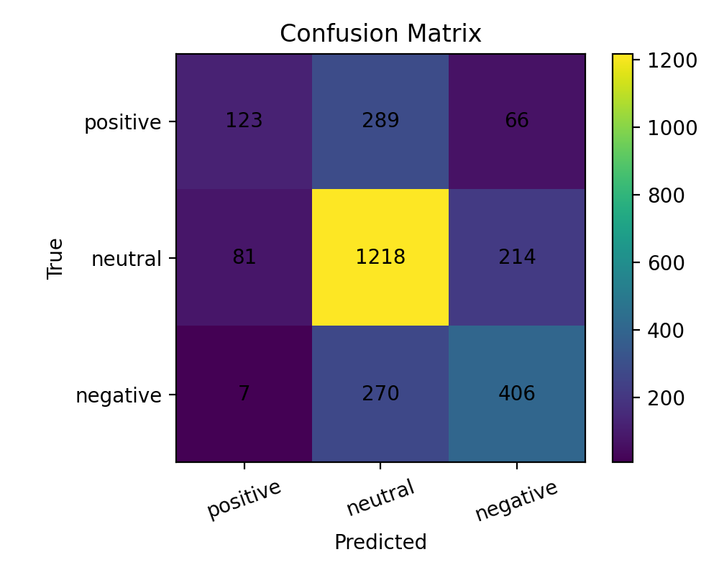

9.1.3 Confusion Matrix on Multilingual model
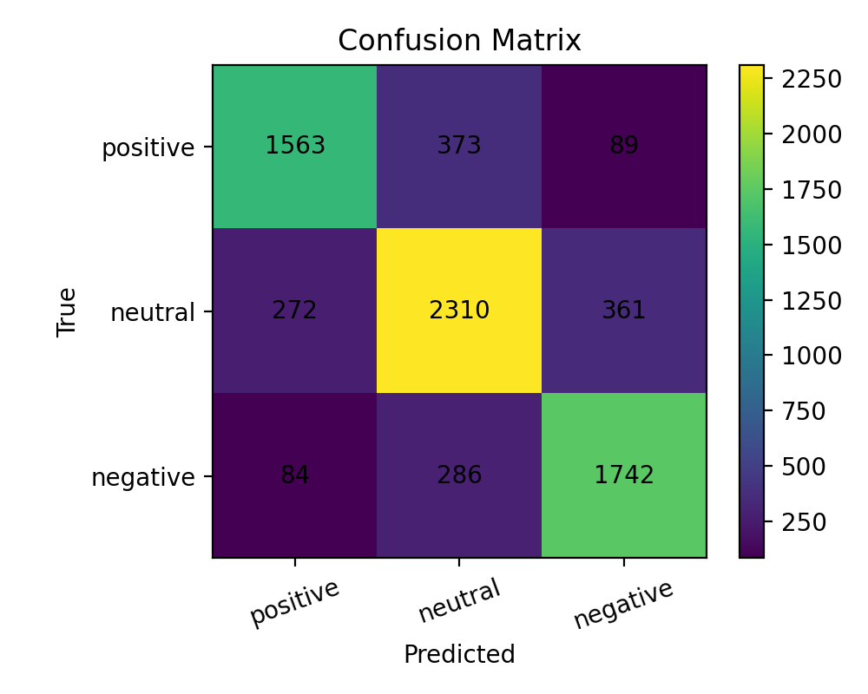
9.2 Per source metrics
English vs. Multilingual
 | SST2 | Twitter
English | Positive (precision: 0.9287356321839059,  recall: 0.9099099099099078, f1: 0.9192263936286218),  Neutral (precision: 0.0, recall: 0.0, f1: 0.0),  Negative (precision: 0.9084668192219658, recall: 0.9275700934579417, f1: 0.9179190751440064),  Macro_Avg (f1: 0.6123818229242094),  Accuracy (0.9185779816513762) | Positive (precision: 0.866793529971455, recall: 0.8259292837715315, f1: 0.845868152274337),  Neutral (precision: 0.7681355932203385, recall: 0.7923076923076918, f1: 0.7800344234074169),  Negative (precision: 0.8085317460317452, recall: 0.8141858141858134, f1: 0.8113489298153279),  Macro_Avg (f1: 0.8124171684990272),  Accuracy (0.8089983022071308)
Multilingual | Positive (precision: 0.9061135371179019, recall: 0.9346846846846826, f1: 0.9201773835915158),  Neutral (precision: 0.0, recall: 0.0, f1: 0.0),  Negative (precision: 0.9322033898305062, recall: 0.8995327102803716, f1: 0.9155766944109128),  Macro_Avg (f1: 0.6119180260008096),  Accuracy (0.9174311926605505) | Positive (precision: 0.8350137488542615, recall: 0.8259292837715315, f1: 0.8304466727433462),  Neutral (precision: 0.7751479289940824, recall: 0.7328671328671325, f1: 0.7534148094890757),  Negative (precision: 0.7607699358386795, recall: 0.8291708291708283, f1: 0.7934990439765557),  Macro_Avg (f1: 0.7924535087363257),  Accuracy (0.7891907187323146)
Thai vs Multilingual
 | Wise-Sight
Thai | Positive (precision: 0.5829383886255897, recall: 0.257322175732217, f1: 0.35703918722744044),  Neutral (precision: 0.6854248733821043, recall: 0.8050231328486446, f1: 0.7404255319143963),  Negative (precision: 0.5918367346938767, recall: 0.5944363103953139, f1: 0.5931336742142543),  Macro_Avg (f1: 0.5635327977853637),  Accuracy (0.6533283470456245)
Multilingual | Positive (precision: 0.6405405405405388, recall: 0.4958158995815889, f1: 0.55896226415045),  Neutral (precision: 0.7809405940594055, recall: 0.8341044282881687, f1: 0.8066474912107496),  Negative (precision: 0.7659883720930221, recall: 0.7715959004392375, f1: 0.7687819110133572),  Macro_Avg (f1: 0.7114638887915189),  Accuracy (0.7576664173522812)

9.3 Analysis of Misclassified Examples
English model
- Neutral ambiguity: tweets labeled neutral but read as emotional, so the model forces polarity (e.g., “best night…”, “my poor baby girl…”, “so blessed…”).
- Slang/short context: informal phrases like “I lost so bad / I suck…” are predicted negative though labeled neutral; some “negative” labels look like noise (“i wear a lot of white…”).
- SST-2 subtle tone: review sentences with positive-sounding words (“compelling”, “riveting”) get predicted positive even when labeled negative, and vice versa (“cross-promotion”, “inept”).
Thai model
- Informational/product posts: price/item descriptions are predicted neutral though labeled positive (promotion-like content lacks explicit sentiment words).
- Desire statements: “อยากกิน…” is predicted positive though labeled neutral (craving is interpreted as positive).
- Short check-in/review style: short location/food posts lack clear sentiment markers, causing neutral predictions.
Multilingual model
- Strong SST-2 failures: many negative movie-review lines are predicted positive with very high confidence (likely idioms/indirect negativity and/or decision-boundary shift from mixed training).
- Short neutral tweets: generic replies (“will do”) predicted positive instead of neutral due to little sentiment content and overconfidence.

10) Discussion
- Thai improvements suggest multilingual training can provide cross-lingual transfer benefits or better regularization for Thai sentiment classification.
- Slight English reductions suggest the English-only model can specialize more effectively for English-specific distribution and slang patterns, while multilingual training may introduce mild interference.
- Dataset differences matter:
- SST-2 is binary (no neutral), which limits direct comparability with 3-class datasets.
- Twitter text is noisy and includes slang/sarcasm, making it a challenging benchmark.

12) Limitations
- SST-2 has no neutral label; mapping into a unified label space creates a mismatch.
- Neutral sentiment is subjective and may vary by dataset definition.

13) Demo with Python CLI
Example usage with a question which can be considered as Neutral

With English text input
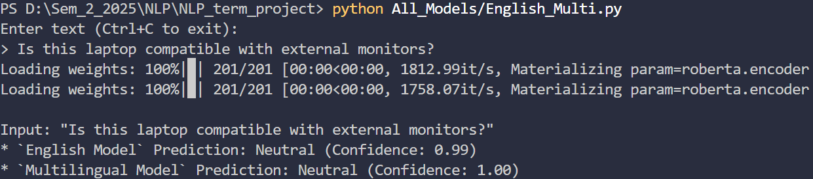
With Thai text input (Same Question with English)
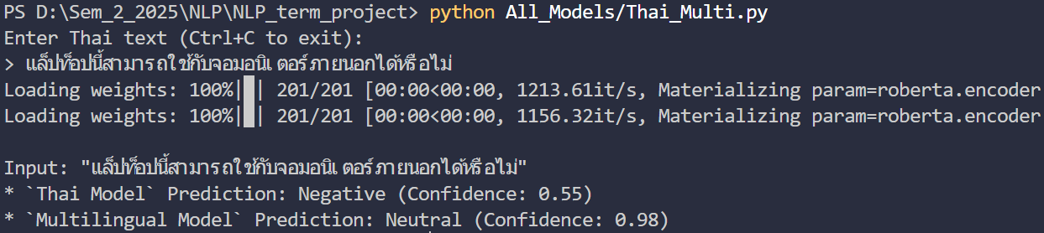

14) Conclusion
A multilingual sentiment model can significantly outperform a Thai-only baseline on Thai evaluation (Wisesight), while introducing small performance trade-offs compared to an English-only baseline on English datasets. For deployment, the multilingual model offers simplicity and strong Thai performance, while a routed monolingual approach may remain preferable if optimizing purely for English accuracy.

14) Reproducibility
- A/B comparisons:
- Run: python Final_Evaluation/Comparison.py
- Output: final_report_ab_results.json
- Confusion matrices and misclassified examples:
- Run: python Final_Evaluation/Evaluation.py
- Outputs in: final_report/

15) References
- Wisesight Sentiment Corpus (Thai)
- GLUE SST-2 (English)
- XLM-RoBERTa base (multilingual transformer baseline)

